**Evolved population ploidy assay**

*Adapted by K. Fisher from protocol supplied by M. Fumasoni*

Thaw FD plates on the bench for 45 min. For each sample well, resuspend pellet and transfer 10ul of culture into a 5 ml YPD O/N culture. Inoculate haploid and diploid O/N controls.

**Day 1** *Spins in 4*°*C cold room*

In the AM, dilute cultures back 1:50 (100ul into 5ml) and let grow to mid-log (4 – 5 hr). *For analysis of G1 arrested cultures, follow the inset step below. Otherwise, move on to the 5- minute spin.*

To arrest in G1, transfer 1ml midlog culture into 200ul 1M hydroxyurea (1M HU) in a 1.5 ml tube. Incubate 3h on 30°C roller drum.

Spin mid-log cultures (1500 rpm, 4°C) for 5 min. Discard media and wash once w/ 5ml H2O.

After decanting the H2O wash, resuspend the pellet in the small residual volume of H2O. *Transfer to a 1.5ml tube if not already.*

Add 1 ml 70% EtOH and immediately vortex 3 seconds. Leave O/N at 4°C.

**Day 2 (afternoon or evening)** *Spins in 4*°*C cold room.*

Spin fixed yeast (1500 rpm) 5 min. Aspirate supernatant and resuspend in 1 ml Tris-HCl.

Spin (1500 rpm) 10 min. Gently remove supernatant with a pipette.

Resuspend in 500ul Tris-HCl. Add 20ul RNAse A solution. *(Alternatively, 520ul of RNAse/Tris mastermix.)*

Sonicate with 3 low pulses and incubate O/N at 37°C. *IA C112 sonicator – flip switch to “continuous” and turn pulse to output of 4 watts for 1 second, 3x.*

**Day 3 (morning)**

Spin (1500 rpm) 5 min. Aspirate supernatant.

Resuspend pellet in 200ul Tris-HCl. Add 20ul proteinase K. *(Alternatively, 220ul of protK/Tris mastermix.)* Incubate at 50°C 30 minutes.

Spin 5000 rpm for 5min. Aspirate supernatant.

Resuspend pellet in 500ul Tris-HCL. The sample is stable for several weeks when stored at 4°C.

**DNA staining**

Before FACS reading: Transfer 100ul fixed sample to a foiled FACS tube and add 1 mL of Sytox green staining solution. Sonicate. *IA C112 sonicator – flip switch to “continuous” and turn pulse to output of 7 watts for 3 seconds, 3x* Sample is ready for FACS

**Reagents**

* 1M HU *Stored at 4*°C.
* 50 mM Tris-HCl pH 7.5.
* RNAse A (10mg/ml) *Kept in yellow box at -20*°C.
* Proteinase K (20mg/ml) – *Kept in yellow box at at -20*°C.
* Sytox green (Molecular Probes) -*Store at -20*°C.

Dilute 5mM stock to 1mM in DMSO *(aliquots already made)*

* Sytox green staining solution *Make fresh each assay. Keep foiled.*

1ul/ml of Sytox green in Tris-HCl pH7.5.

1 uM final sytox

**FACS**

Duplicate the DNA staining protocol without data. In the Cytometer window, check to make sure that FSC, SSC, and FIT-C are all checked. The voltage setting for FIT-C should be around 440. Click on specimen, and check to make sure that the flow rate in the Acquisition window is set to low.

Click New Tube and load your haploid control. Click Acquire Data. If the G2 cluster (the top of the inverted L) is not at approximately 100, adjust the FIT-C voltage slightly until the distribution is from 50 to 100 (diploid controls should likewise be distributed from 100 to 200). *For HU assays – the haploid cluster should be at 50 and the diploid cluster should be around 100. Use controls to verify these.* The optimal voltage may vary day to day, but should hover between 440 and 460. *For HU assays sometimes voltage needs to be lowered to around 430.*  Once the voltage is set, click Record Data to record your control data.

Click New Tube to run your next sample. After clicking Acquire Data, wait 10 seconds before clicking Record Data. The first 10 seconds of data is apparently crap. Repeat for all samples. Export FCS files and analyze in FlowJo. **FlowJo Analysis**

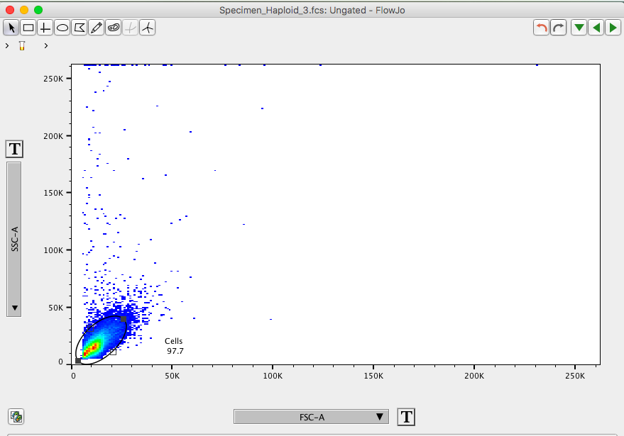

View data first by SSC-A and FSC-A. Apply an ellipse gate called “cells” to gate out noise.

The “cells” gate can typically be applied to all samples

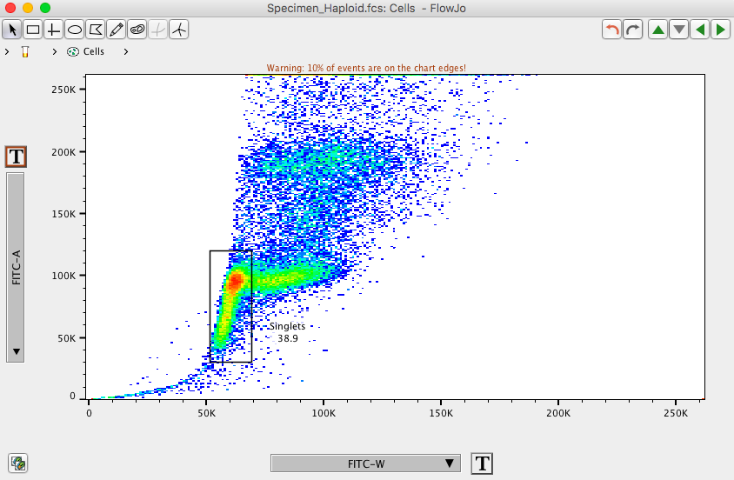

Double click in the “cells” gate. Switch the axis to FITC-A on the y and FITC-W on the x. Make sure they are both scaled linearly (can be changed by clicking on the **T** button next to the axis label). The plot will resemble an inverted letter L. In haploid samples, the inverted L will run from ~50K to ~100K. In diploids it will run from ~100K to ~200K. Gate single cells, “singlets”, by using a vertical rectangle gate around the y axis of the L. Exclude the x axis of the L, these cells are doublets. The “singlets” gate can be applied to all replicates of the same sample, but will may need to be adjusted for different samples.

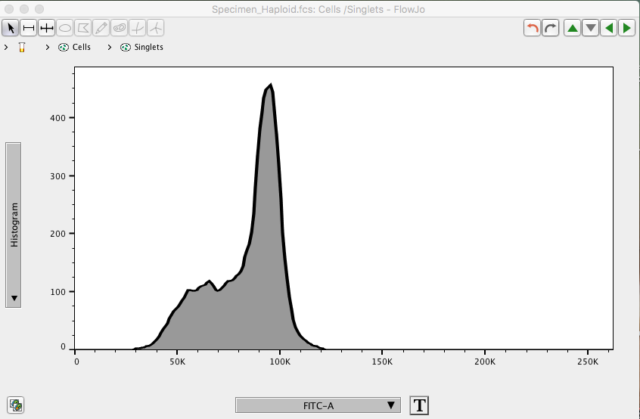Double click on the “singlets” gate. Switch the axis to Histogram on the y and FITC-A on the x. The result is a histogram of frequency of cells with 1N/2N or 2N/4N DNA content. The examples given are of 432, our ancestral *MAT****a***.

**Cell Cycle Analysis**

FlowJo v. 10.3 has a Cell Cycle tool that will fit FITC-A histograms to a Watson Pragmatic model. For a more detailed explanation of this tool and the model, refer to FlowJo’s Cell Cycle Tutorial. For clean histograms in which a distribution is readily fit to G1 and G2, the model will automatically be fit to the data with no adjustment. The example below is 672 (ancestral diploid).

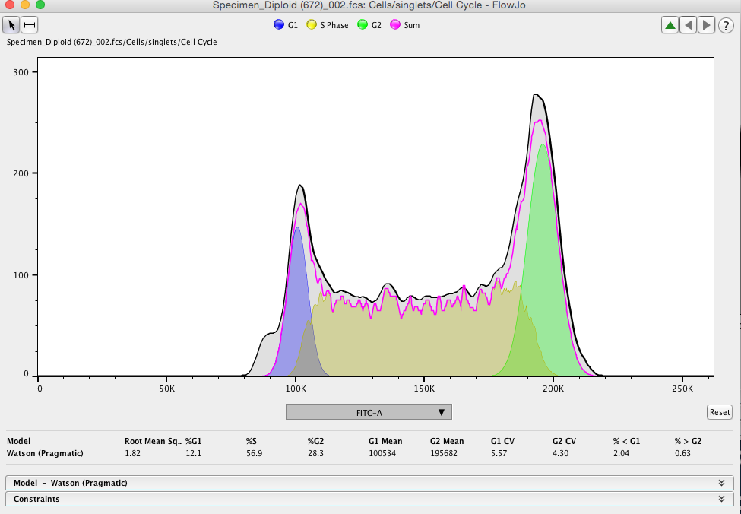

To fit the model, select the “singlets” gate and click the Cell Cycle button. In the new window, select FITC-A on the x axis. The model will identify a G1, S, and G2 distribution. The root mean squares (RMS) statistic provides a measure of the error of the fit (based on the distance of the composite model from the histogram), the lower the RMS, the better the fit. The “cell cycle” icon will appear below the “singlets” gate. This can be dragged to all samples.

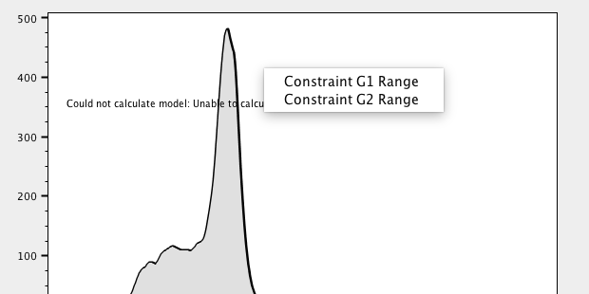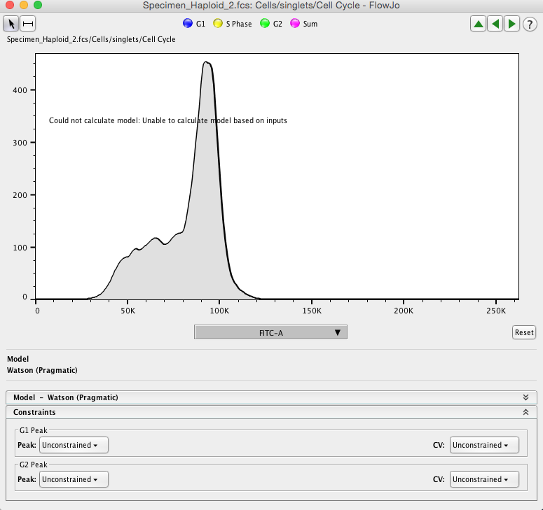Some samples won’t be automatically fit to the model. For these samples, you will need to tell the model where G1 or G2 should be. Drag your mouse across the larger peak (usually G2) to apply a constraint. Text will appear for you to select which cell cycle phase this peak is constrained to.

To tell the model where to constrain G1, click on the Constraints tab. Under G1, select Range=G2 x n. The default n value will be .5. This will instruct the model to constrain the G1 peak to half the pulse area of G2. The result will resemble the model fit above. If the G1 peak looks abnormal or wacky, next to CV select =G2 CV. This will instruct the model to make the 2 curves the same shape, and that should correct the G1 fit.

After all cell cycle models have been adjusted for all samples, click the Table Editor icon and drag the Cell Cycle icon from the first sample into the Table Editor window. A table of statistics will appear:

\**RMS* – Root mean square error. A measure of the error in the fit of the model.

%*G1, S, G2* - Frequency of cells assigned to each phase by the model.

\**G1/G2 Mean* – Mean pulse area (fluorescence) under each curve.

*G1/G2 CV - Coefficient of variation under each curve.

%<G1, >G2 – Frequency of cells sub G1 or super G2.

All the statistics without an asterisk aren’t necessary for ploidy analysis, so these can be cleared from the table. *(Note- The RMS statistic does not export. I have no idea why. I save the table as an .xls file and manually enter the RMS values.)*  Ploidy analysis can be performed by plotting the G1 means. The data should sort cleanly into two modes representing haploid samples and diploid samples.